**Project Synopsis On**

**HUMAN RESOURCE MANAGEMENT**

**SYSTEM**

By

**Supriya Poojary 48**

**Sanskruti Sankhe 53**

**Meghna Ushinkar 63**

**Department of**

**Information Technology**



**Vidyavardhini’s College of Engineering & Technology**

**University of Mumbai**

**2020-2021**

**Vidyavardhini’s College of Engineering & Technology**

**Department of**

**Information Technology**

**CERTIFICATE**

*This is to certify that the following students*

**Supriya Poojary 48**

**Sanskruti Sankhe 53**

**Meghna Ushinkar 63**

*have submitted project report entitled*

**HUMAN RESOURCES MANAGEMENT SYSTEM**

*as a part of their MINI-project-work in partial fulfilment of III semester*

*S.E. INFORMATION TECHNOLOGY*

*course during the academic year 2020-2021.*

|  |  |  |
| --- | --- | --- |
| Internal Guide | : ________________________ | ( ) |
| Internal Examiner | : ________________________ | ( ) |
| External Examiner | : ________________________ | ( ) |

|  |  |
| --- | --- |
| _____________________ | _____________________ |
| Dr. ASHISH VANMALI  HOD, EXTC | Dr. HARISH VANKUNDREPRINCIPAL, VCET |

**Abstract:**

The systems and processes at the intersection of human resources management and information technology is known as Human resources management system. The HR management system provides the information regarding the employees to the HR. The system facilitates good communication between the employees and the HR administration.

An information hierarchy is maintained i.e the information regarding particular employee is accesses by the same person or a person above him in the hierarchy. The web pages about the employee are created dynamically based on the username and password. A web page is provided to the employees for posting their suggestions, grievances, queries to the HR. The HR can view the query on his page. HR admin page is created with admin tasks. The administrator is provided with the facility to view the query, the employee details, to add new employee details, to delete and update details. The HR can deliver tasks to the employee which the employee can see on his task page. The employee can send a leave request to the HR specifying the number of days, the reason for leave. The HR can view the leave request on his side and respond accordingly. The project will help the HR head of an organization to handle employee data more efficiently. The employees can communicate efficiently with the HR.

**Introduction:**

Human resource management is the strategic approach to the effective management of people in an organization. In any organization, maintaining employee data is really important for the efficient working of the organization. The aim of the project is to build a system that keeps track of the employee data at the organization.

Two types of users can access the system:

a)HR user

b)General employee user

Functionalities:

1. The company HR can login with his user id and add an employee record to the system.
2. The HR can search the employee record by employee id.
3. The HR can update an existing record.
4. The HR can delete an existing record.
5. HR can search and see the list of employees working in a particular department.
6. The employees can login with their password to view their details.
7. The employee can send a leave request to the HR.
8. The HR can view the leave request of the employees and accept or reject it accordingly.
9. Anyone can contact to HR through the website.

**Description:**

The HR can manage tasks such as adding employee details, handling leave requests and queries, assigning tasks to employees efficiently. The employee can also interact efficiently with the HR management. The employee can view his details, send a leave request, send queries to the HR and clarify any doubts.

Flow chart:

Add new record

Update record

Delete record

Search record

Handle leave

View details

Send leave request

Ask query

General employee

HR

Login

password

Main

ER diagram

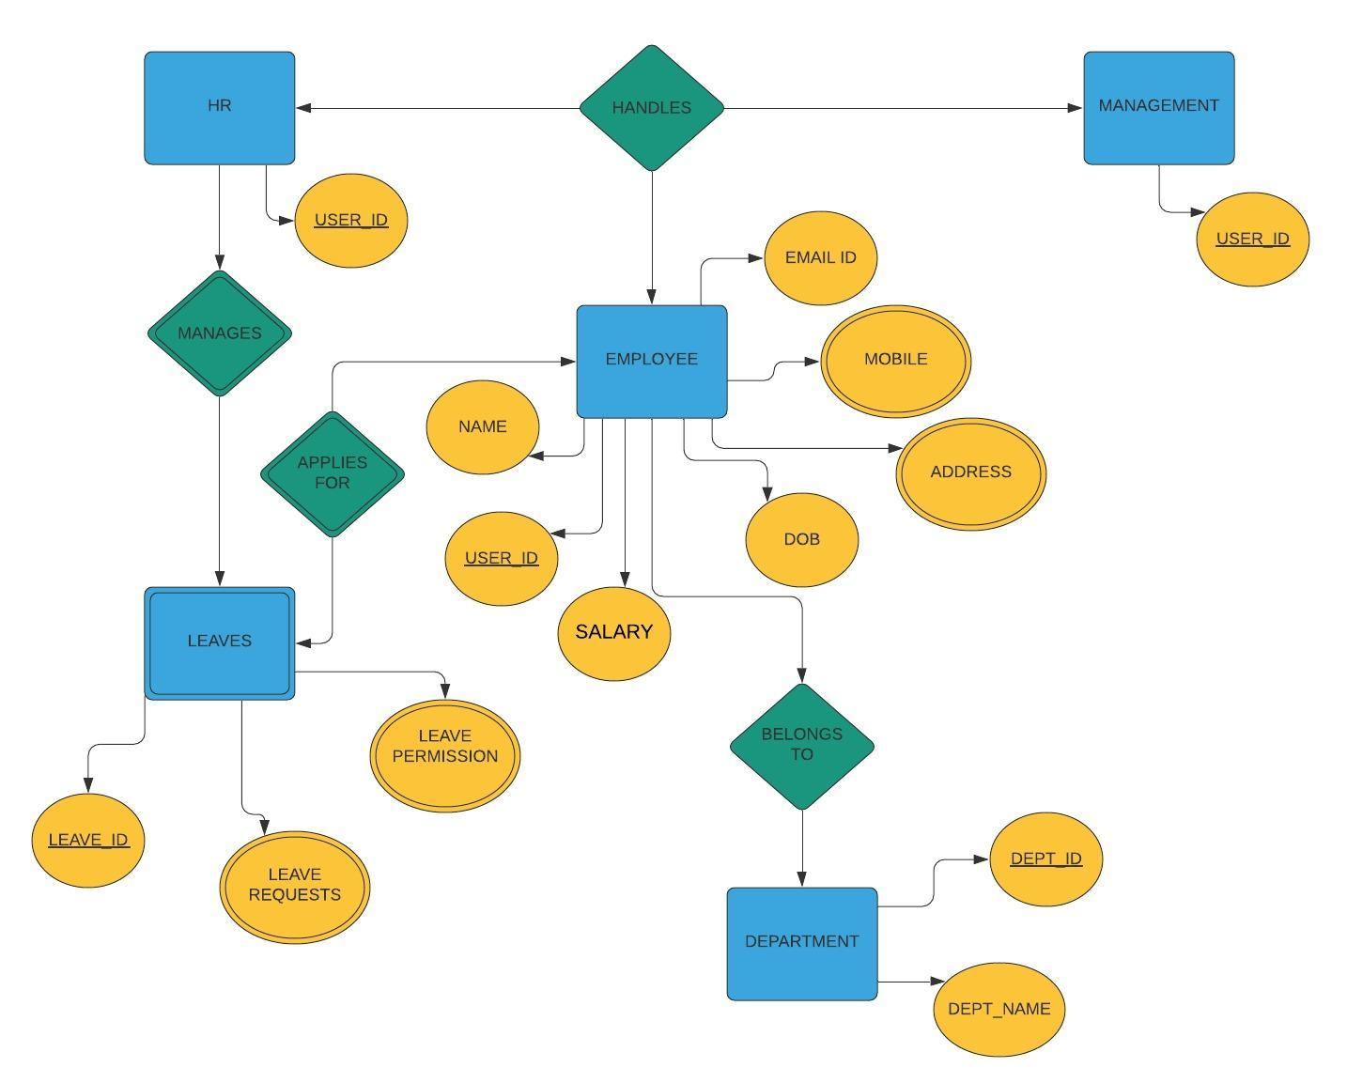

Figures:

Home page: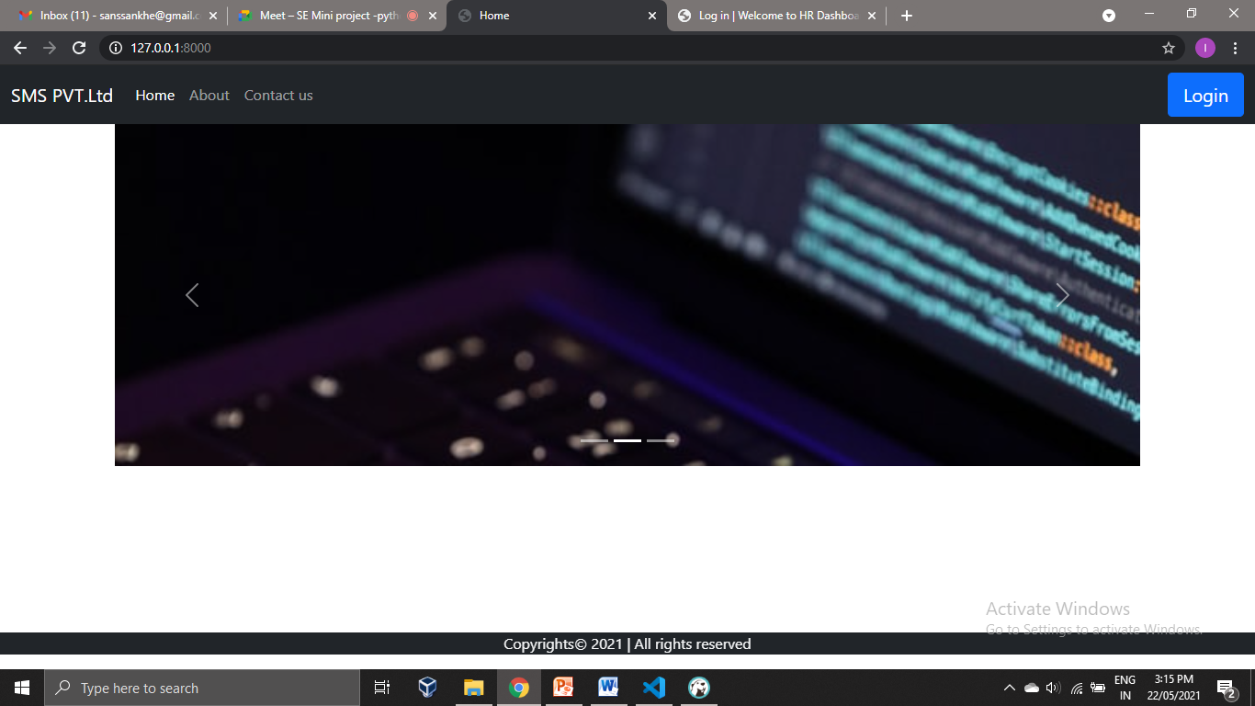

Contact us page:

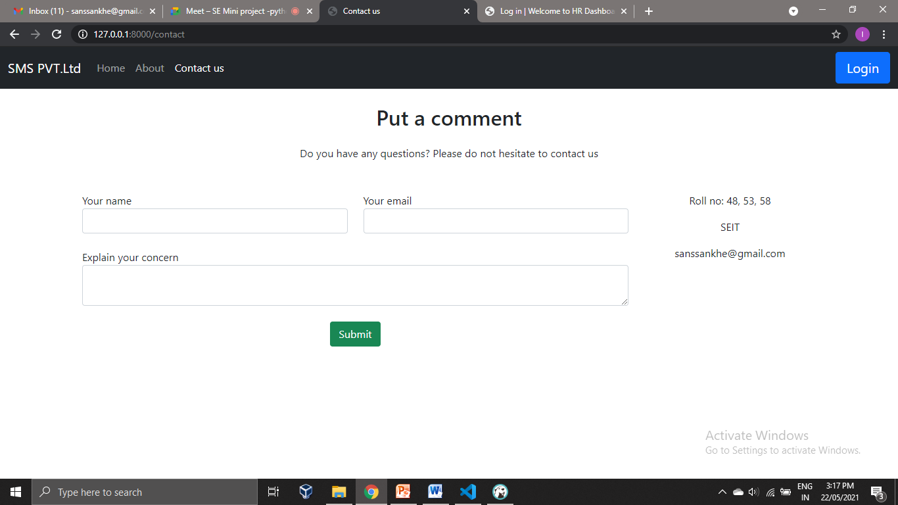

Login page for employee:

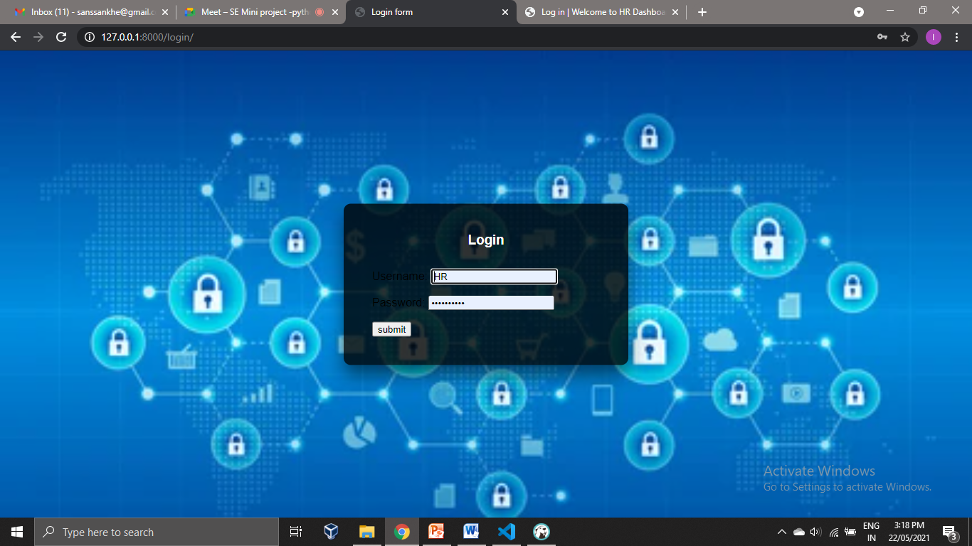

Home page for employee:

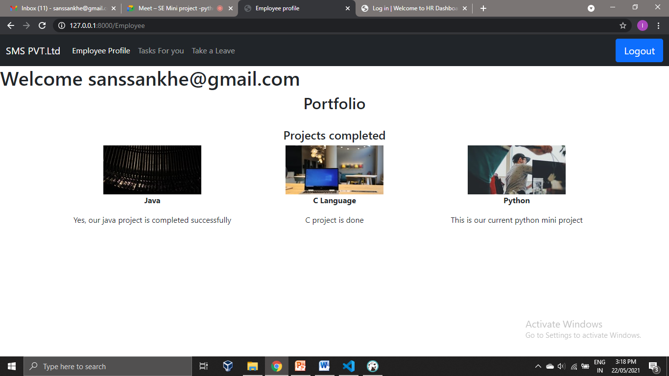

Task page:

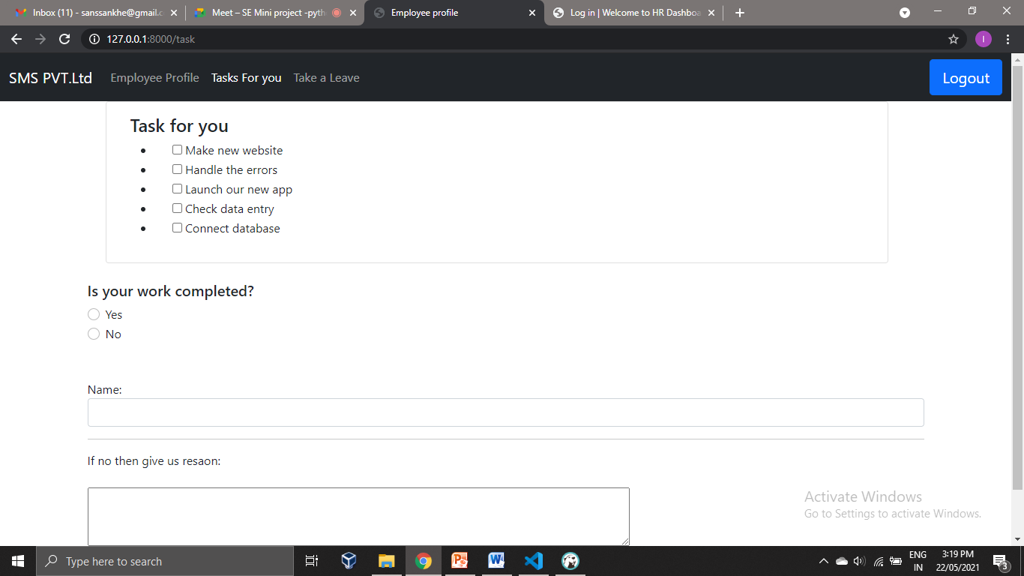

Leave page:

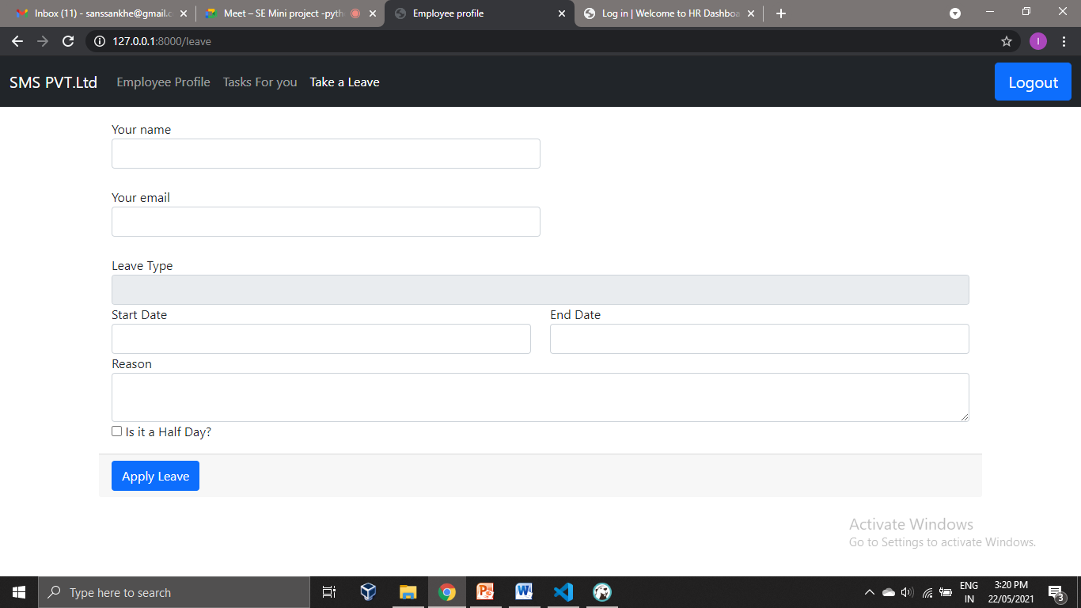

**Conclusion and further work:**

The project can be improved by adding more security to it and providing major access and functionalities to the HR. More features such as payroll management, recruitment management, training can be added to further enhance the functions of the HR and simplify the process for the employees.